**Notification Service**

Architecture Diagram :-

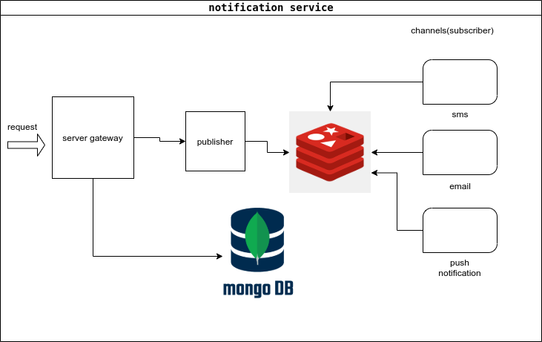

How to run it :-

1- install [Docker](https://via.placeholder.com/468x300?text=App+Screenshot+Here)

2- run in development mode use this command

> docker-compose -f docker-compose.yml -f docker-compose.dev.yml -d --build

Integration:-

By calling api /addRequest on port 3000 with body

{

"usersList": [{

"userIdentifier": "01015842240",

"preferredLang": "arrLang",

"templateData": {

"name": "mohamed"

}

},

{

"userIdentifier": "01015842240",

"preferredLang": "engLang",

"templateData": {

"name": "ahmed"

}

}],

"messageID": "60d49fd758172b23fe386a30",

"channel": "PUSH",

"expireAt": 1999314790830,

"sendAt": 0,

"retry": 2

}

Future improvements :-

1- provide a dashboard for monitoring messages life cycle .

2- integrate with real providers .

3- provide a reporting system to summarize the status of requests and messages.